

**KULLIYYAH OF INFORMATION & COMMUNICATION TECHNOLOGY**

**CSCI 3302**

**SEMESTER 1, 2022/2023**

**SECTION 2**

**ARTICLE RESEARCH**

**PREPARED BY:**

|  |  |
| --- | --- |
| **NAME** | **MATRIC NO.** |
| MUHAMMAD YUSOFF JAMALUDDIN | 2016799 |

**LECTURER**

MADAM LIYANA

PART I UNDERSTAND FROM THE PAPER

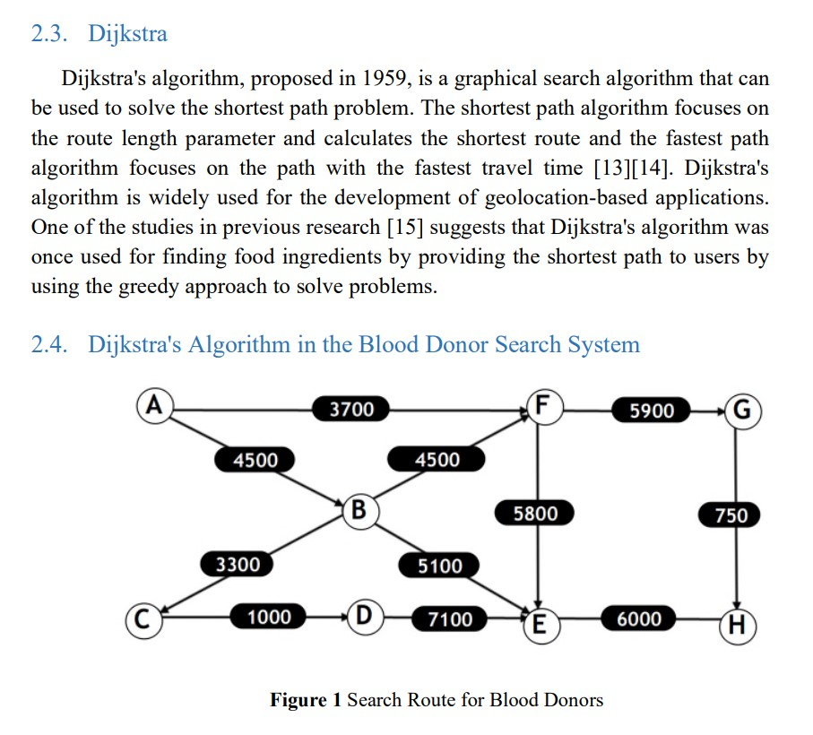

Figure Using Dijkstra in distance estimation as diagram

PART I DON’T UNDERSTAND

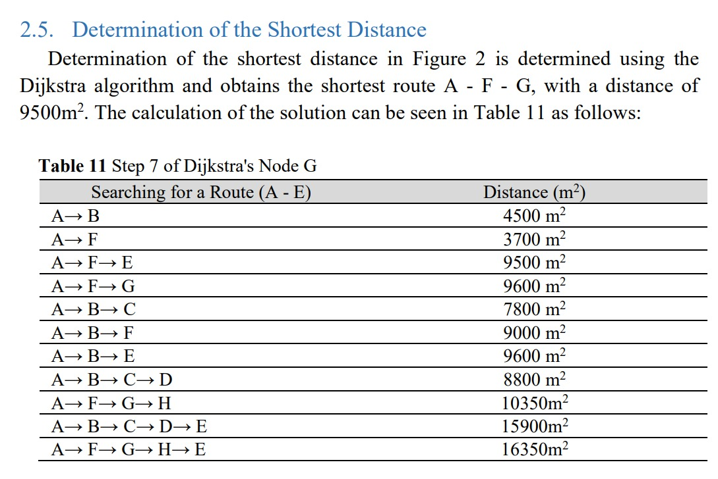

Figure Why calculate the other roads when already found the shortest distance initially?

MODIFIED DIJIKSTRA ALGORITHM

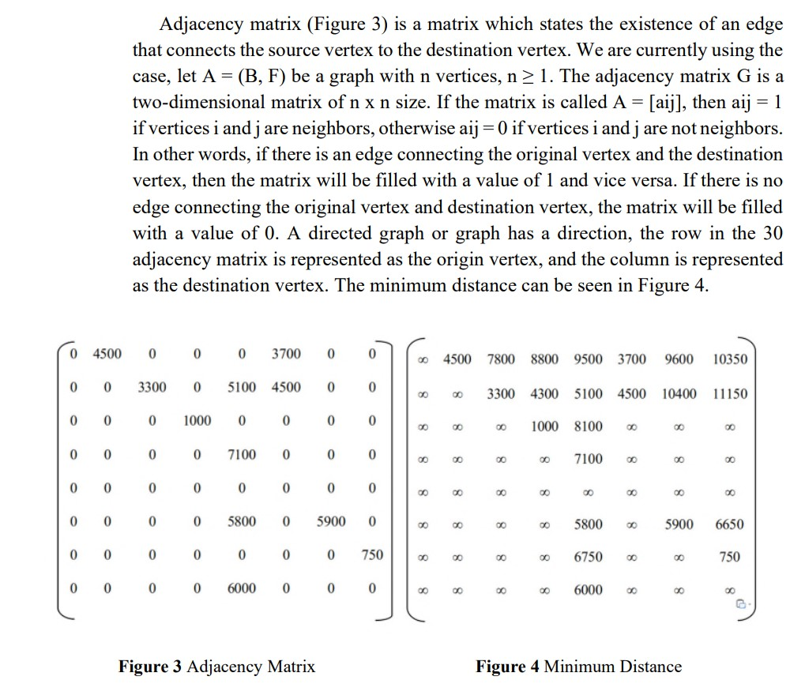

Figure Modified part of the algorithm

The paper using matrix and compare it to the minimum distance it get from the calculation previously